CREATE JAVA APPLICATION

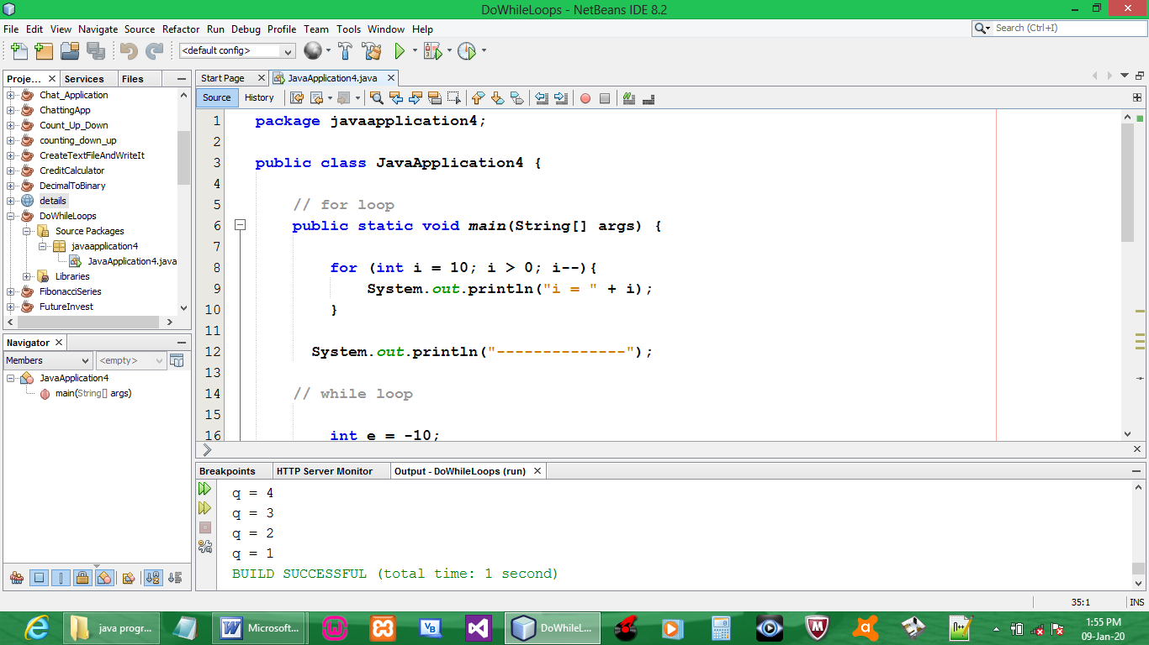

CODE:

package javaapplication4;

public class JavaApplication4 {

// for loop
public static void main(String[] args) {

for (int i = 10; i > 0; i--){
System.out.println("i = " + i);
}

System.out.println("--------------");

// while loop

int e = -10;

while(e <= 0){
System.out.print(" e = " + e + "\n");
e++;
}
System.out.println("--------------");

// do while loop

int q = 10;

do{
System.out.println("q = " + q);
q--;
}while(q > 0);
}
}

OUTPUT:

